1. MAC address

ether: 00:0c:29:97:17:77

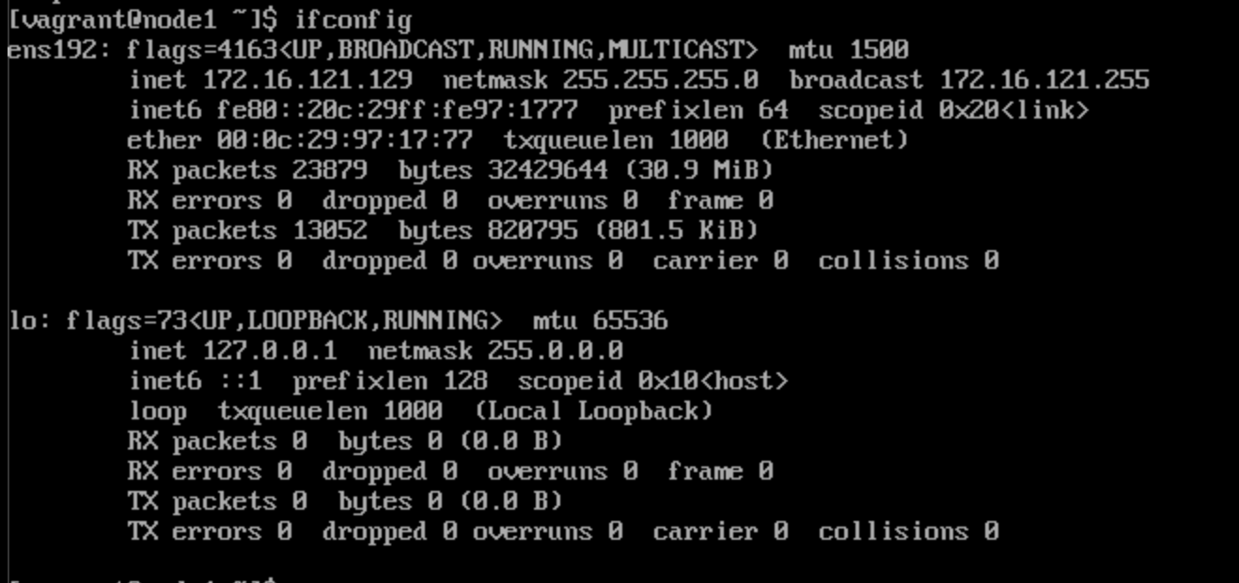

1. Local ARP table

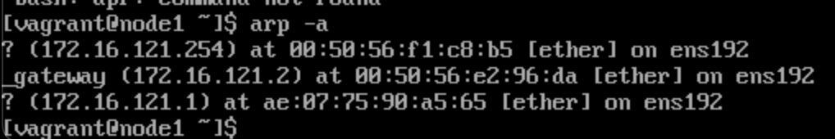

1. Network interfaces and associated IP addresses

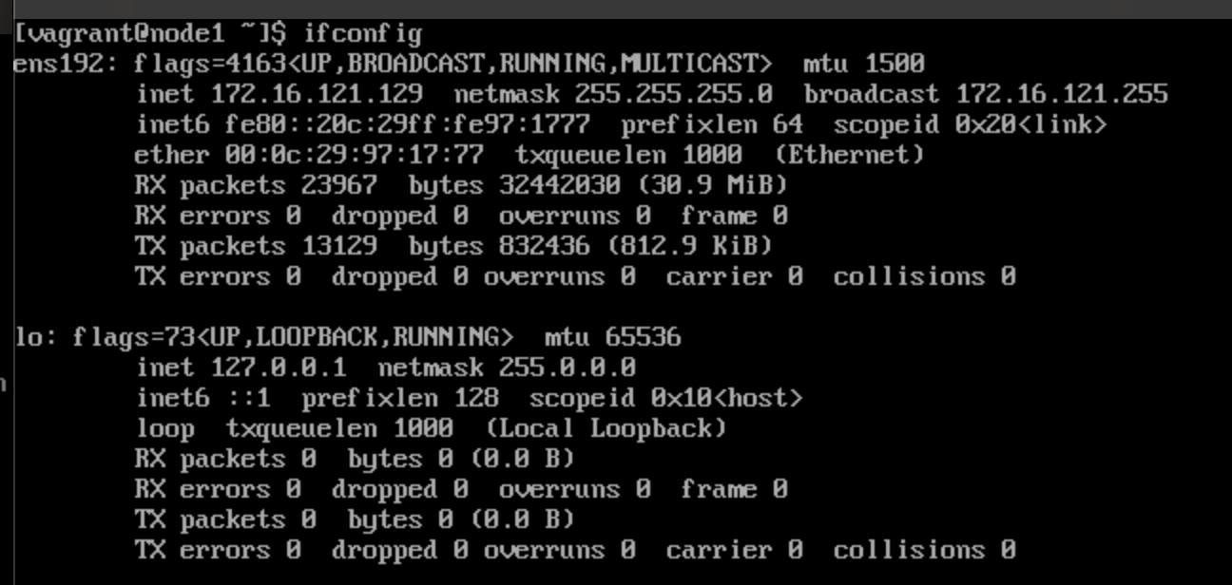

1. Route table

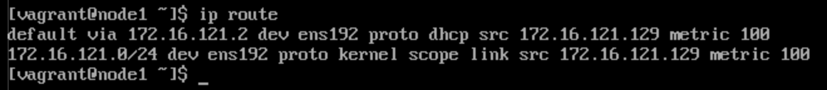

1. List of open (listening) TCP ports

